Civil war in Liberia

UNSC Resolution: | 866
Date of adoption: | 22-Sep-1993
Operative paragraph: | 7
Demand number: | 866,0711

Sarah-Myriam Martin-Brûlé

Wording of demand
- commence the encampment, disarmament and demobilization process without delay

List of addressees of the demand

Government of Liberia, Liberian Peace Council, National Patriotic Front of Liberia, United Liberation Movement of Liberia for Democracy

Short-term compliance

Description of the addressee(s)’ conduct

“The members of the Council note that, pursuant to resolution 866 (1993) of 22 September 1993, a report is expected by 16 February 1994. They are concerned that the
transitional government has still not been installed, disarmament has not yet commenced, that the implementation of the Cotonou Agreement is thus being delayed, and that efforts to deliver humanitarian assistance to all parts of the country have met with difficulties. “

Repertoire 1993-1995- Liberia
http://www.un.org/Depts/dpa/repertoire/93-95/CHAPTER%208/AFRICA/item%2005-%20Liberia.pdf

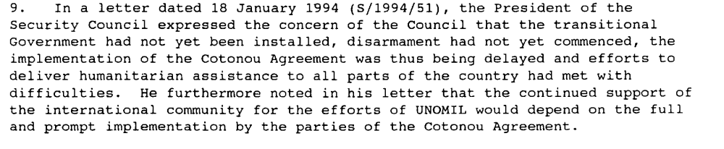

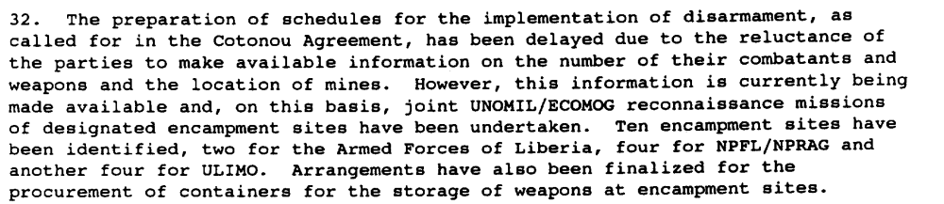

Report of the Secretary-General, S\1994\168, 14 February 1994

Assessment

Short-term compliance
No or marginal compliance (1) | X Medium low compliance (2) | Medium high compliance (3) | Full or almost full compliance (4)

Considerations underlying the assessment
The encampment began slowly yet the disarmament and the demobilization process were delayed and did not commence within the six months following the adoption of the resolution.

Medium-term compliance

Description of the addressee(s)’ conduct

“The Council is gravely concerned at the delays in implementing the commitments
entered into by the parties under the Cotonou Agreement, in particular the commencement of disarmament and the installation of the transitional Government

The Secretary-General noted that during the period of negotiations between the
parties on the distribution of the remaining posts, the pace of disarmament had slowed
considerably. With the installation of the Transitional Government, the parties had
recommitted themselves to the complete implementation of the Cotonou Agreement,
including disarmament. It was therefore expected that the pace of disarmament would
quicken. The Secretary-General again called on the Liberian parties to respect the timetable for disarmament and to ensure that their combatants laid down their arms.”

In May 1994, the following statement was issued:

“The Council notes with concern, however, the continued fighting among and within
factions. Political differences and renewed violence among and within certain factions have caused the disarmament process to come to a virtual halt. The ongoing hostilities make it very difficult for the Mission to accomplish critical elements of its mandate and prevent the peace-keeping troops of the Monitoring Group from carrying out their functions regarding disarmament and demobilization, a situation which directly threatens the ability of the parties to maintain the timetable outlined in the Cotonou Agreement and the communiqué of 15 February 1994 (S/1994/187, annex).

The representative of the United States stated that UNOMIL was sent in to
observe a cease-fire, but the firing had not ceased. Instead, UNOMIL observers had been
abused and humiliated by the warlords whose country they had come to protect.
Humanitarian relief workers had come to help, yet they had been harassed and treated
inhumanely. The Secretary-General had been right to pull out two-thirds of the UNOMIL
observers. They should not go back until there was a real cease-fire, assumption of
authority by a transitional Government and a commitment to disarmament by all the
factions. In the view of the United States, given the precarious situation in Liberia, they
should not go back until the Security Council decided to send them back

Repertoire 1993-1995- Liberia
http://www.un.org/Depts/dpa/repertoire/93-95/CHAPTER%208/AFRICA/item%2005-%20Liberia.pdf

“Due to the lack of Liberia-wide security and the failure of ECOMOG's infantry companies to reach all their agreed locations, disarmament and demobilisation sites were not opened in all of the areas originally proposed. On arrival at an established site, fighters received clothing, rations, digging tools and transport to a community of their choice. After an initial flow of personnel and weapons from each faction (except the LPC), disarmament came to a standstill by June 1994 except for a small trickle of variously motivated fighters heading for Monrovia. The lack of accurate information about the factions, or their disregard for truthful declaration, was demonstrated by the extreme disparity between the estimated figures (for example see "weapons" and "ammunition" below) and the greater or lesser figures received. »
(Mackinlay & Alao 1995)

Assessment

Medium-term compliance
No or marginal compliance (1) | X Medium low compliance (2) | Medium high compliance (3) | Full or almost full compliance (4)

Considerations underlying the assessment

Depth of demand

Assessment

Level of depth of demand
Low depth of demand (1) | Medium depth of demand (2) | X High depth of demand (3)

Considerations underlying the assessment

Encampment, disarmament & demobilization jeopardized the survival of each party. There were no guarantees of compliance from each of the demand addressee. The failure of one addressee to comply with such resolution posed a great threat to the others.

The following reasons have been identified.

“[The factions] don't trust each other. No one wants to start giving up his arms first. This is where the problem lies. Whether you bring them to Monrovia and make them members of the council of state and you give them the confidence that they need to disarm is a problem...”
http://www.unhcr.org/refworld/country,,WRITENET,,LBR,,3ae6a6b814,0.html

“The reluctance to demobilise seemed to be motivated by a complex web of local conditions in which no single cause could be isolated. Individual fighters who demobilised seemed to have planned for the next stage of their life and had aspirations for employment or resettlement. The corollary may be that the majority did not have such prospects, and it was more secure for them to remain in the factions. It is not clear to what extent the failure to provide for a "new national army" in the Liberian reconstruction plans added to the fear that demobilising the factions would lead to greater anarchy. Taylor himself voiced this anxiety, but it is doubtful whether at grass roots level the perception of a security vacuum would in itself have deterred young men from coming forward.”

In the past negotiators of intercommunal conflict have set great store on "disarming" as though it was a concept which would somehow drive the peace process towards its goals. In the planning process it has been cited as the key to success, but in the epilogue often the principle reason for failure. Despite the enthusiasm of third party negotiators to disarm the parties involved, few intercommunal conflicts have experienced verifiably successful disarmament. Even in peace processes where the final outcome has been apparently "successful", subsequent investigation has shown that the most powerful factions cheated on the process, reserving a military capability until the outcome was clear. For several reasons it is now questionable whether the instinctive urge to have warring factions disarmed as soon as possible is not counterproductive to the overall effort to establish conditions for a lasting peace process. No population that has 'survived in' a war zone for several years can expect to be absolutely disarmed.

There will be too many residual weapon caches to monitor, and consequently impossible to guarantee that factions could not swiftly rearm when the need arises. Nor can disarmament be conducted in isolation. First there must be convincing reasons to disarm, an environment in which weapons become redundant, rusty and unserviceable impediments to the more important problems of finding shelter and gainful employment. This is only likely to happen when individual security can be assured by a higher authority or regime in which the individual does not have to fend for himself. In a collapsed state, it is when a super-gang or military force which is superior to the sum of all the parties in the immediate area, possibly nation-wide, can establish itself. In some cases the regime that provides this condition of local security may not be democratically elected, even behave in a brutal and unjust manner. The question that the designers and negotiators of a peace process have to decide is whether a despotic regime is easier to bring into a peace process than the array of sub-factions and local gangs spawned by a partially successful disarmament process that has robbed the district of its super gang which previously guaranteed individual security.
In Liberia there is no convincing super-gang or a pervasive nation-wide military force. Only the factions acting within their own areas can exercise this stabilizing condition locally. For example in Gbarnga the NPFL had established the embryo of an alternative state within Liberia. In summer 1994 Gbarnga had begun to take on the functions of a capital, in which Taylor's staff and HQ compound assumed a presidential character. Livestock presented by heads of state grazed on the lawn, a "presidential" guard supervised security around the HQ. In Gbarnga town goods were traded for the NPFL's own currency and considering the circumstances there were reasonable arrangements for policing, security of vital installations, a civil radio station and a hospital. However by the summer of 1994 the lessening or removal of the threat also diminished Taylor's control. In common with other faction leaders, the prospect of being able to regulate the possession and carriage of weapons even within their own areas was fast diminishing. In each faction, eroding coherence, subdivisions and intra-factional rivalry reduced that likelihood. Individually the unpaid faction fighter still needed his personal weapon for his own survival. If he managed to scrape an honest living from the land he became vulnerable to those that were still armed. In the Liberian context it maybe useful to learn from the Cambodian and Angolan failures. It may be more realistic to accept that without the interim presence of an effective third party military force or in the worst case scenario a super-gang to ensure individual security, disarmament is not a viable concept at national level. Individual security may only be possible within the aegis of each faction. This must lead to the unusual view that instead of negotiating to weaken the factions by disarmament, in the short term stability may be improved by encouraging them to be stronger and more centrally controlled. Rather than attempting to disarm in isolation, it is probably more fruitful to create an environment in which weapons become increasingly less important to individual survival by improving the linked conditions of the economy and reconciliation, at the same time increasing the tempo of political exchanges between faction leaders rather than in the case of Liberia relying on their proxy representatives in the LNTG.
(Mackinlay & Alao 1995)

Level of confidence about coding decisions

Level of confidence about coding decision
Extremely high | X High | Moderate

Comments to IPI (if any)

